

**A Shift in the Balance of Risks**

## Speech given by

David Walton, Member of the Monetary Policy Committee, Bank of England 18 May 2006

1

All speeches are available online at [www.bankofengland.co.uk/publications/Pages/speeches/default.aspx](http://www.bankofengland.co.uk/publications/Pages/speeches/default.aspx)

For the past nine months, the Monetary Policy Committee of the Bank of England has left interest rates unchanged at 4.5%. But, as the minutes revealed yesterday, at the most recent MPC meeting on 3-4 May, I dissented from the majority view to vote for a 25 basis points interest rate increase. I would like briefly to explain the reasons for my vote.

The Committee’s latest projections for consumer price inflation were published in last week’s *Inflation Report*. When conditioned on unchanged interest rates at 4½ per cent, the Committee’s central projection was for inflation to rise above the government’s 2 per cent target in the near term and then to remain slightly above target throughout the next two years (see Chart 1). While there is no mechanical link between these projections and policy decisions, I judge that the balance of risks to this central projection for inflation lie a little to the upside; hence my vote for higher rates.

**Chart 1. May 2006 *Inflation Report* CPI inflation projection based on constant nominal interest rates at 4.5%**

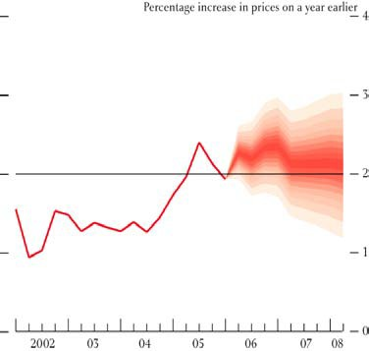

Note: The fan chart depicts the probability of various outcomes for CPI inflation in the future. For a full description, see the footnote to Chart 2 on page iv of the May *Inflation Report.*

What are these risks? First, I believe that there is a modest upside risk to the Committee’s central projection for GDP growth, and hence inflation. In the central projection, GDP growth picks up a little in the second quarter and then remains close to its long-run average throughout the forecast period. Growth could easily be a bit stronger than this in the rest of 2006. After a period of weakness during 2005, growth in the UK economy has been running close to trend in the past couple of quarters. But there are indications from a broad range of business surveys that the pace of output growth has now increased to an above-trend rate.

Looking at the expenditure components of GDP, there is still great uncertainty about the underlying strength of household spending. The Committee, though, does not expect consumer spending growth to be particularly strong in coming quarters. In the Committee’s central projection, consumer spending grows a little below its post-war average rate of increase during the next couple of years.

There are risks in both directions. Households’ real disposable incomes will be squeezed by higher energy prices and a continued rise in the effective tax rate but support for spending should come from improving employment intentions, past rises in equity prices and the upturn in the housing market seen in recent months.

I see upside risks to growth in two areas: exports and investment. The world economy continues to grow at a robust rate and, of particular importance from a UK perspective, there are now indications of much greater momentum in economic activity in the euro area. This is reflected in improved export sentiment in UK business surveys.

These surveys have also signalled a notable strengthening in investment intentions recently after several quarters of weak readings. Given healthy corporate cashflow and the historically low cost of capital, it would be surprising if UK companies continued to stand apart from the strengthening trend in capital spending that is evident worldwide.

Second, I see a small upside risk to inflation stemming from a little less spare capacity in the economy currently than implied by the Committee’s central projection. The UK economy has had to absorb a sizeable shock from higher energy prices since the end of 2003 and it is quite possible that this has depressed temporarily the growth of potential output.1 Labour productivity growth ground to a virtual halt in the year to 2005Q3. While this may mostly have been cyclical, it could also have reflected a slower pace of capital accumulation and a drop in measured total factor productivity growth if some capacity had been scrapped. Consistent with this, there has not been much net change in capacity utilisation over the past couple of years according to business surveys, despite below- average recorded GDP growth.

1 For a detailed analysis of the oil shock and its implications for monetary policy, see “Has oil lost the capacity to shock?” Bank of England Quarterly Bulletin, Spring 2006.

The labour market has loosened – the unemployment rate has risen by 0.5 percentage points since last summer – and wage inflation has remained subdued, but this is not conclusive evidence of cyclical weakness. In the face of higher oil prices which raise firms’ costs, the real consumption wage (ie the post-tax wage paid to workers deflated by consumer prices) must be lower than it would otherwise have been in the absence of the oil shock, if firms are to maintain employment. Although wage inflation has remained stable, and growth in the real consumption wage has eased (see Chart 2), this has not prevented a rise in the growth of the real product wage (ie the full cost of labour to firms divided by the price firms get for their output).2 This suggests that some of the rise in unemployment might have been related to structural factors.

# Chart 2. Growth in real wages

Percentage changes on

a year earlier

7

Real production wage

Real consumption

wage

6

5

4

3

2

1

0

-1

1997 1998 1999 2000 2001 2002 2003 2004 2005

Note: Real production wage uses GDP deflator at basic prices. Real consumption wage uses National Accounts household consumption deflator.

A third risk relates to commodity and import prices. In framing its projections, the Committee takes the path for oil prices given by the futures market, which is currently fairly flat. The outlook is highly uncertain but in the face of continued strong global growth, and periodic worries about supply, the risks to oil prices are probably still to the upside. And there are big uncertainties too about the future path of gas prices.

2 The extent to which the real consumption wage must fall depends on the size of the oil price change, the shares of oil and labour in gross output and the degree of complementarity between factors of production. Following a doubling in oil prices, estimates of the required fall in the real consumption wage to maintain employment range from 1 per cent to 2½ per cent. The required fall in the real consumption wage depends on how easily producers can compensate for higher energy prices by substituting away from energy. The smallest fall in the real wage would be generated if energy use could be adjusted flexibly so as to keep the energy share of gross revenue unchanged. The largest fall in the real wage would be implied if instead the quantity of energy inputs had to be used in a fixed proportion to the output produced. For further details, see reference in footnote 1.

After several years in which the level of UK import prices had been broadly stable, import price inflation has turned positive over the past eighteen months. This mirrors trends in export price inflation in the major industrialised economies, as well as China, and it is not just a reflection of higher energy prices. In making its forecasts the Committee assumed a fairly sharp deceleration in non-energy export price inflation in the major economies, and hence in UK import price inflation. I am concerned that this may not materialise to the extent assumed in the central projection, without a slowdown in the pace of global activity first.

The Monetary Policy Committee has little influence over any of these external price pressures but they could nevertheless have an important bearing on the chances of meeting the inflation target.

A fourth concern relates to the stability of inflation expectations. These have drifted upwards a little this year according to various surveys of households’ expectations. There has also been a rise of about 30 basis points over the past six months or so in 5 year forward breakeven inflation rates from the gilts market (see Chart 3). While these movements are not dramatic, they cannot be dismissed either. With growth moving above trend and a risk of higher imported inflation, there is an increased likelihood of a further shift upwards in inflation expectations.

# Chart 3. Inflation expectations

**Per cent**

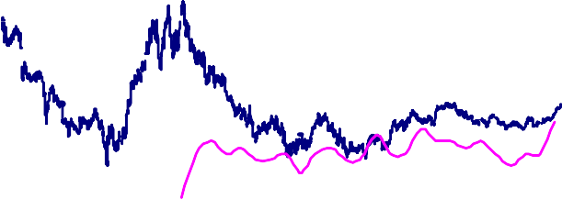

**Implied 5 year forward inflation rate**

**BoE/NOP public**

**attitudes to inflation**

**5.0**

**4.5**

**4.0**

**3.5**

**3.0**

**2.5**

**2.0**

**1.5**

**1.0**

**0.5**

**0.0**

**1997 1998 1999 2000 2001 2002 2003 2004 2005 2006**

Fifth, although difficult to measure with any precision, I judge that the stance of monetary policy is currently somewhat accommodative. This is suggested by asset price developments, including the

renewed pickup in house price inflation since last autumn, rapid broad money growth, and a strengthening in the growth of nominal demand. For the reasons that I have already given, I do not believe that an accommodative policy stance is appropriate at the current time.

I readily accept that there are other risks that could cause growth to disappoint and inflation to undershoot the target. These arguments were advanced by some of my colleagues on the Committee and are summarised in the latest minutes. But for me, in weighing these various arguments, the balance of risks has shifted a little too much to the upside on inflation for comfort. And that, I believe, justifies a small tightening in monetary policy.

ENDS